# User manual

The Eastney Tavern computer system User Manual



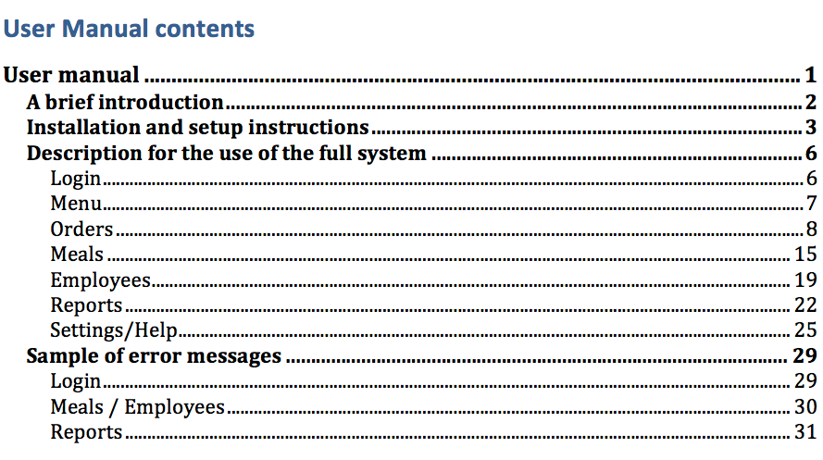

## A brief introduction

This system is a bespoke system designed for the Eastney tavern a Pub and Restaurant in Portsmouth. This system focuses on the restaurant side of the business allowing the waiting staff to order food from the computer at the bar and the orders to be sent to the printer in the kitchen. This system works by first entering base data for employees and meals. Employees can now use the system during service to login to the Orders form, hear they simply enter a table number and select the meals wanted then send this to the kitchen, it also calculates totals and prices so the receipt can be printed off as well. It can also be used to analyse the sales of each meal as well as the performance of the employees and the overall profits made.

## Installation and setup instructions

Select the setup application from the download, USB disk or CD.

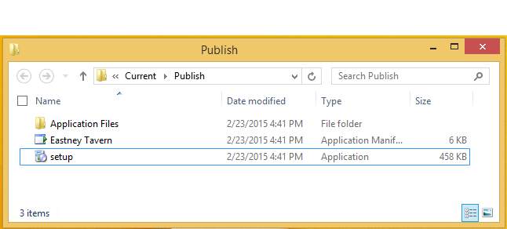

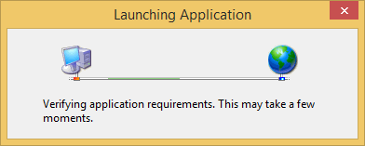

Click install.

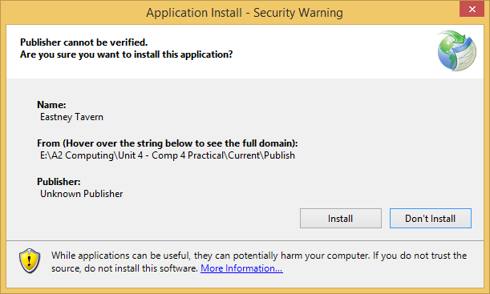

Now the application will open up.

As this is the first time use a message will appear.

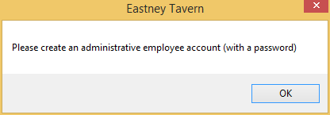

Click OK.

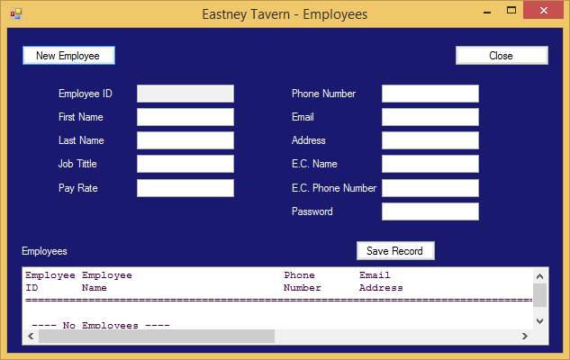

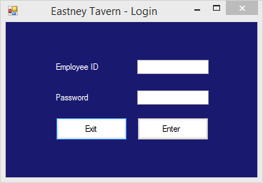

The employee’s form and login form will both appear.

At this point you should create an employee record with a password.

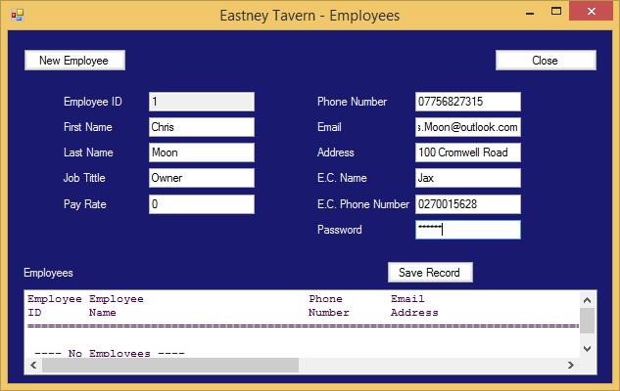

Re-enter the password when prompted.

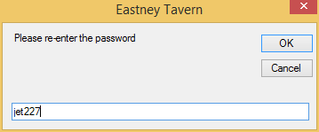

And close the employee form.

Finally enter the newly created employee info into the login screen.

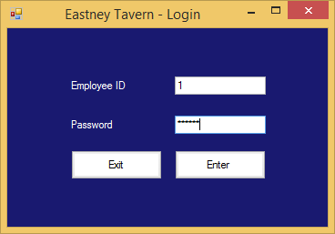

You now have total access to the system.

## Description for the use of the full system

### Login

You can get access to this system in two different ways; the first is without a password. This is how all waiting staff will log in, it’s quicker and you don’t get access to private monetary and performance information. To use this method you simply enter your user ID and you are logged into the orders form.

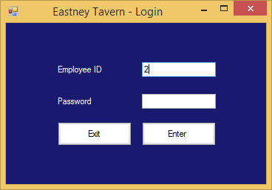

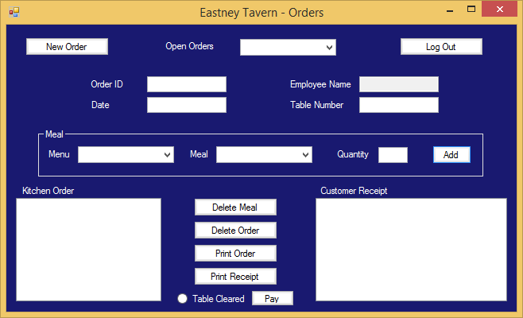

Alternatively, if you are an administrator you can gain access to the full system by logging in using you username and password.

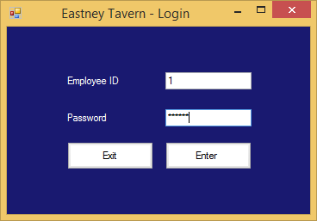

This takes you to the menu form.

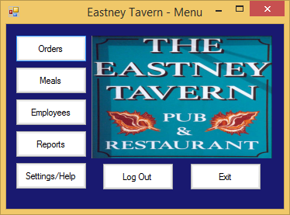

### Menu

From this form you can select any button, the 5 buttons on the left hand side take you to the relevant form, the “Log out” button logs you out and takes you to the Login form and finally the “Exit” button closes the system completely.

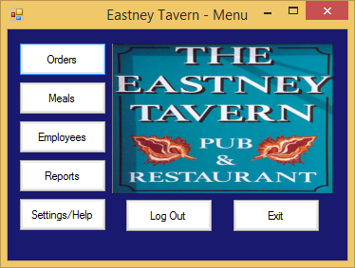

### Orders

The orders form can be loaded in two ways, the only difference is that the “Main Menu” button is a “Log Out” button when you logged in without a password, otherwise the functionality is the same.

#### Creating an order

To create a new order you first have to click the “New Order” button, this will automatically fill the OrderID, Date and Employee Name as well as loading the order to be printed in the kitchen and the receipt for the customer.

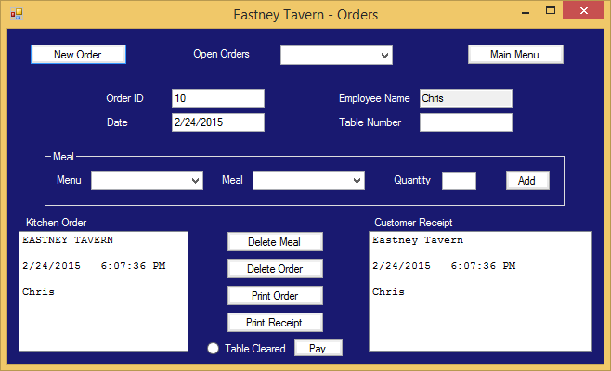

Now write in the table number and use the selection boxes to enter a meal.

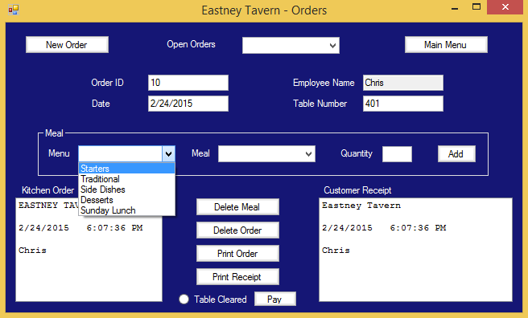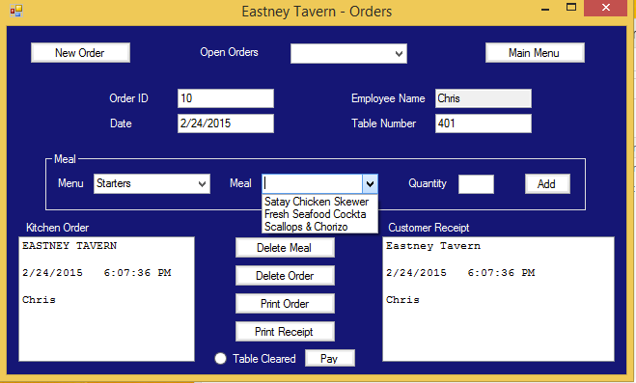

Enter the quantity using the keyboard.

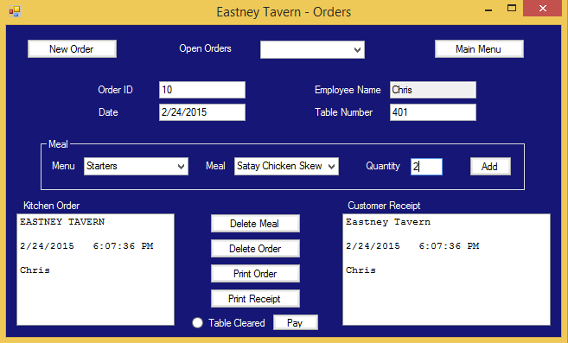

Now press the “Add” button and the meal will be added to the order.

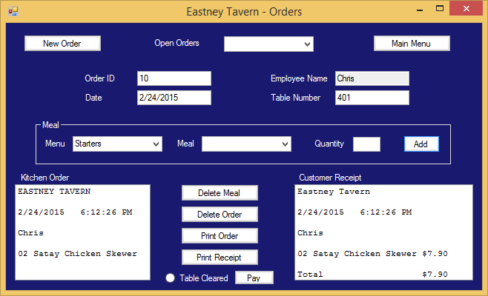

#### Deleting a Meal

You can delete one meal from an order by selecting the meal in either the Kitchen Order box or the Customer Receipt Box.

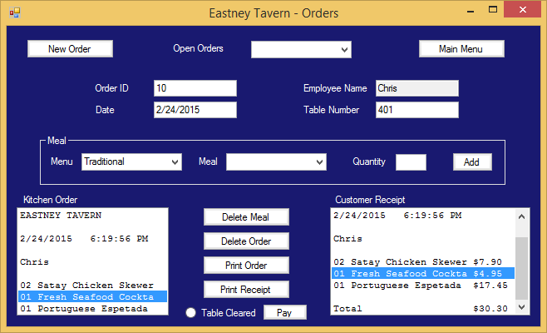

Now the meal is selected press the “Delete Meal” button.

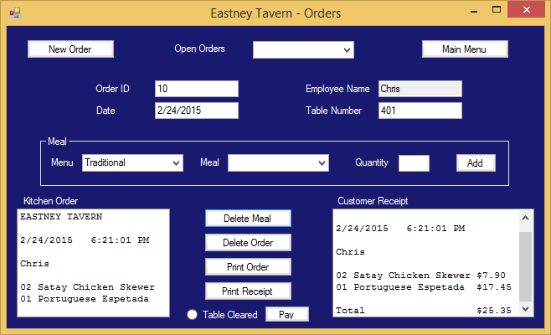

The meal has been deleted.

#### Deleting an Order

To delete an order you have to make sure the order selected is the one you want deleted. To select a different order click the selection box next to “Open Orders” and click the table number you want.

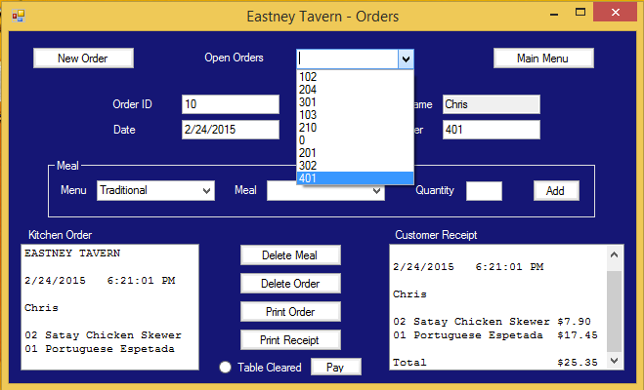

Now all you have to do is press the “Delete Order” button and say yes to the query box.

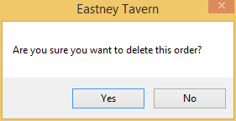

The Order has now been deleted.

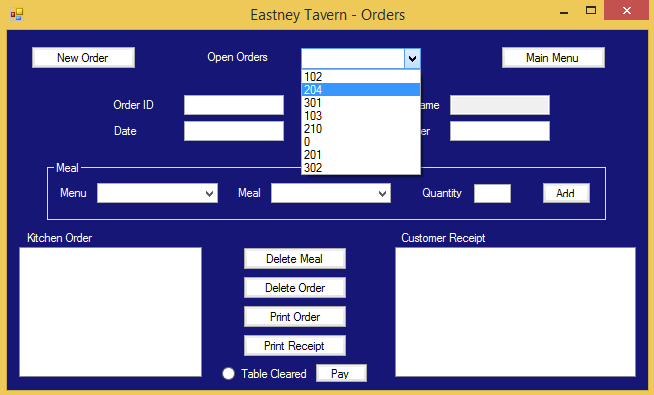

#### Printing

You can print both of the data shown (Customer Report and Kitchen Order), to do this you simply have to click the Print buttons. The Order should be printed to the kitchen printer and the receipt to the printer next to this machine.

Clicking the print button brings up a print dialogue box.

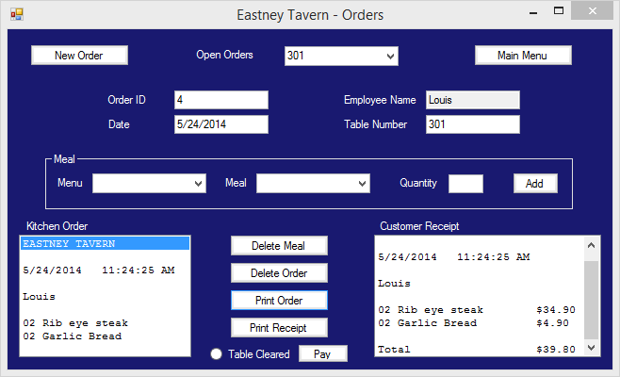

Here you should select the printer you want to print to and click print.

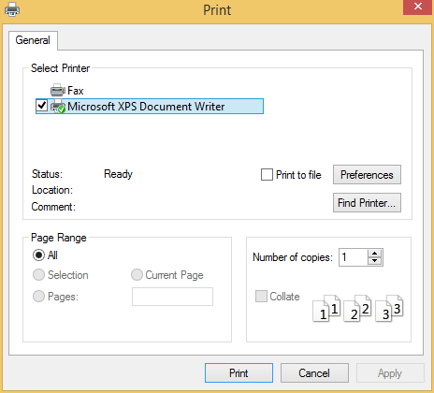

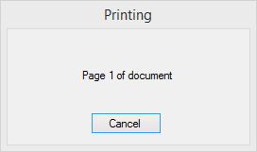

Receipt Print Order

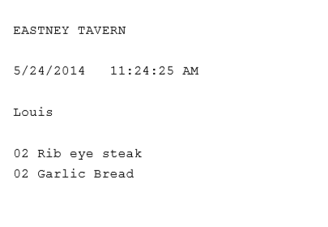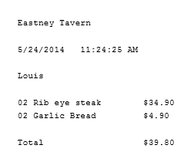

#### Paying (calculating change)

After printing the receipt and the customer pays you, you can now use the “Pay” button to calculate how much change they should be given.

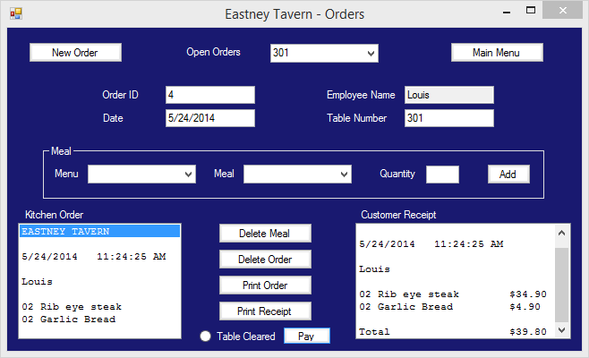

If they have paid with cash click yes.

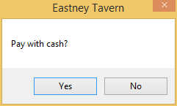

If they didn’t pay with cash this box will appear.

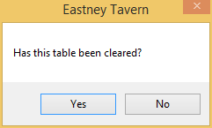

This is asking if the table has been cleared and can now be used by a different group. Clicking yes will remove this order from the order form.

If they did pay with cash then this box will open, in this box you enter the total amount of money the customer paid and click “OK”.

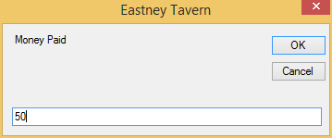

Finally the amount of change you need to give is displayed and again asks if the table has been cleared.

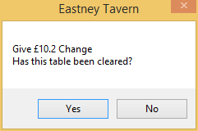

### Meals

This form is where meals can be added or edited as well as displaying all the important information such and price and allergy advice. Every meal has assigned to it a menu and this can be used to search for a specific meal very quickly, using the selection boxes at the top of the form.

#### Adding a new meal

To start adding a new meal you first have to click the “New Meal” button.

The MealID will be automatically created by the system but you have to enter the remaining data, most of this data is self-explanatory but the check boxes will stop the meals being displayed as a possible meal in the order form and the historic check box will remove the meal from all analysis lists.

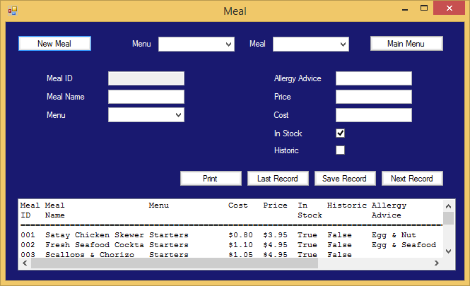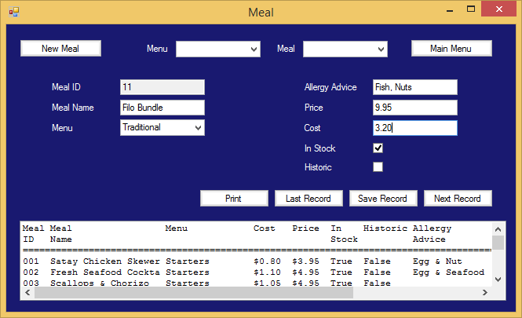

Then press save. 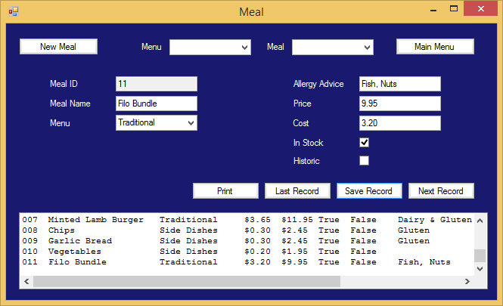

And the meal has been saved.

#### Updating a Record

To Update a Record you simply have to select a meal either by using the selection boxes at the top, clicking on it in the list box or using the “Next Record” and “Last Record” buttons. Now you simply change the data you want changing and click save. After clicking save a message will appear asking if you’re sure you want to update the record, click “Yes”.

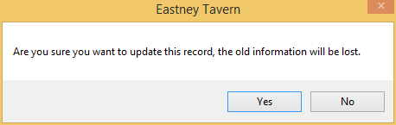

Now all the data is updated.

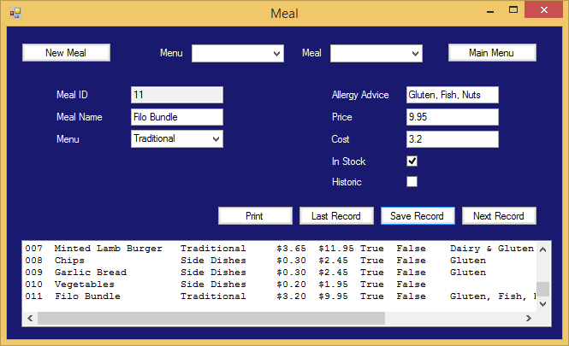

#### Printing

To print the list of meals and all its information you first have to click the “Print” button.

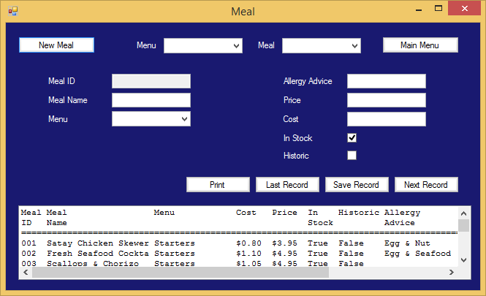

Now a print dialogue will appear and you must select the printer and press print.

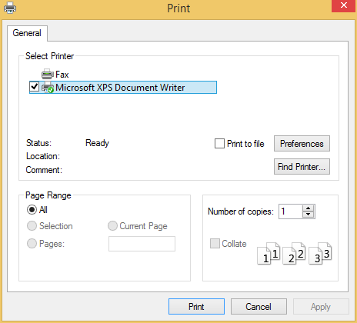

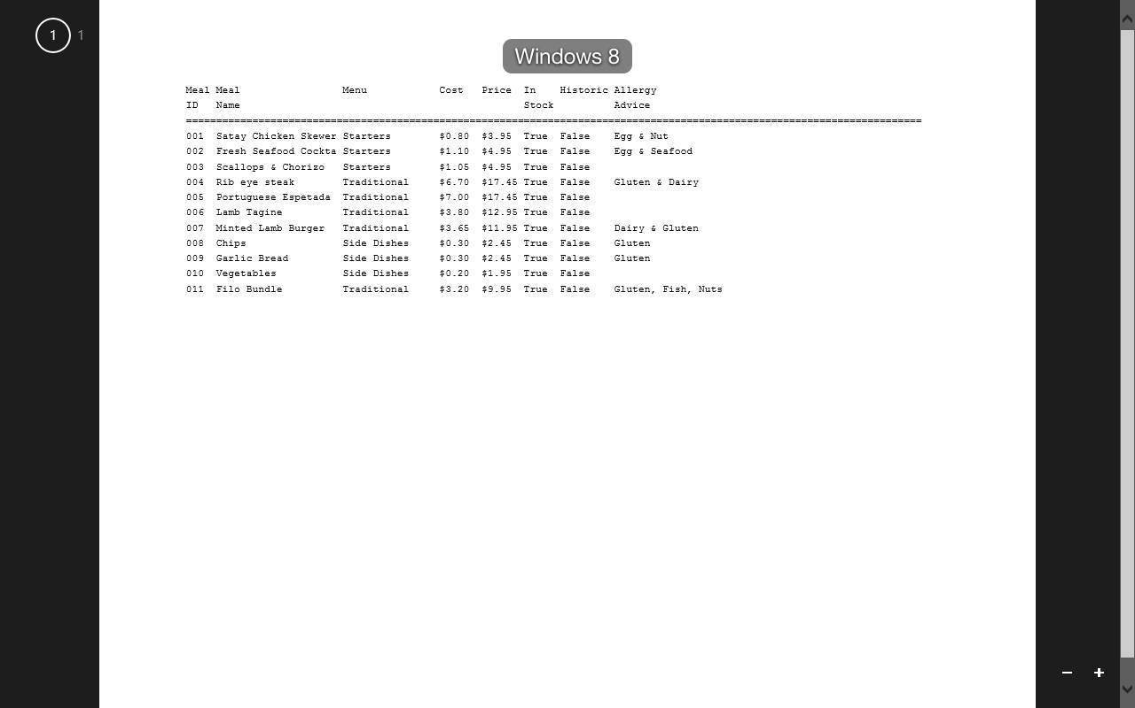

### Employees

The employees form is very similar to the meal form and allows you to add, edit and delete employee information as well as working as an address book.

#### Creating a new employee record

To create a new record you must press the “New Employee” button, this will create a new and unused employee ID and blank out the rest of the boxes ready for you to enter data. At this point you have to decide whether or not the employee will be an administrator, if you wish it to be an administrator then you must enter a password and click Save, this will prompt a message box asking you to reenter the password.

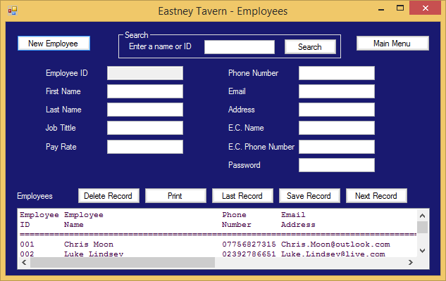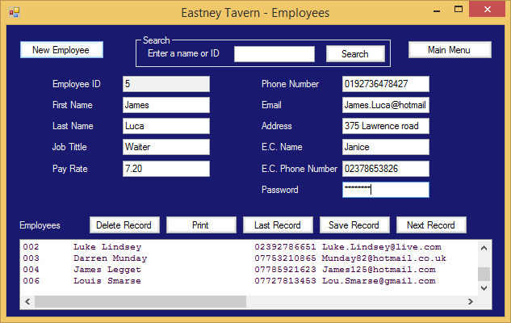

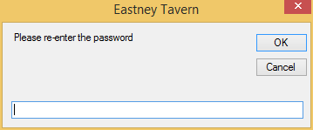

If you don’t want this employee to be an administrator then leave the Password box blank and click save, you then have to agree to the message box.

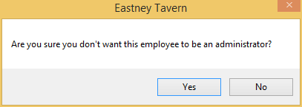

#### Searching

You can search for an employee using the text box at the top of the form. You can search by entering a First name, last name, full name or employeeID and simply clicking the “Search” button.

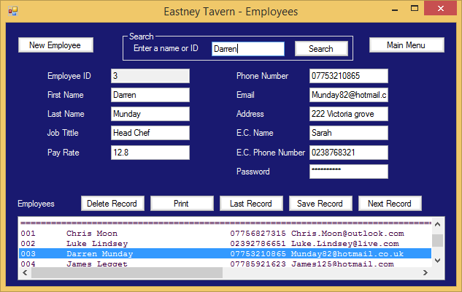

#### Deleting an employee

To delete an employee you must have one selected, you can do this by searching for an employee, clicking on a line in the list box or navigating through the records using the “Nest Record” & “Last Record” buttons. Now you have a record selected just click the “delete Record” button and Press the “Yes” button on the dialogue, which appears.

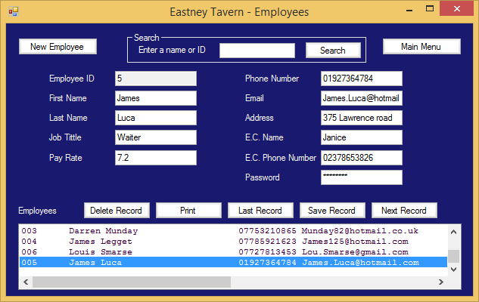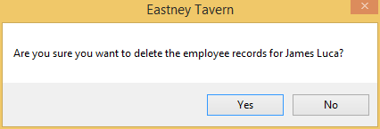

The employee has been deleted.

### Reports

The Reports form is the form used to analyse the data and create useful reports full of information designed to show which meals are selling well, how employees are performing and what profit has been made. You can select the date range you want the report to be between using the “from Date” and “To Date” entry boxes. Once your desired date range has been entered (it will automatically be from the first order to the last order) you can click any of the three buttons, which will then show other buttons.

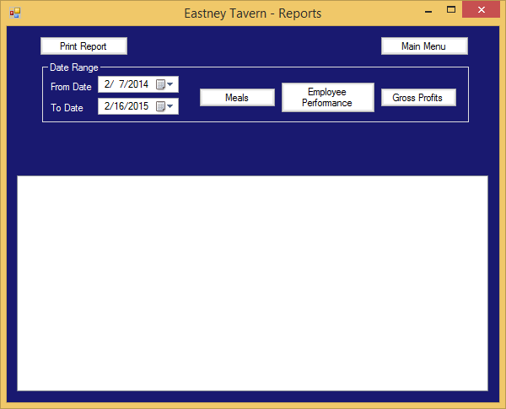

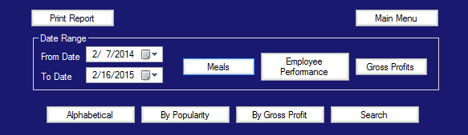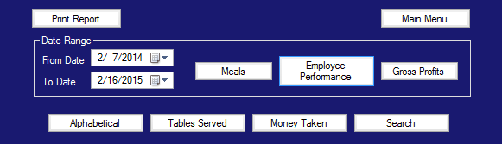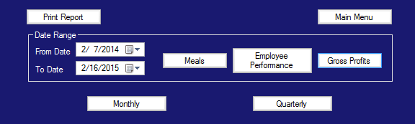

These extra buttons will allow you to order the reports in different way as well as searching for a specific employee or meal by name.

#### Printing

Printing a report is easily, once you’ve created your report you just click the “Print Report” button in the top left corner, this opens a print dialogue where you must select which printer you want it to be sent to and then click “Print”.

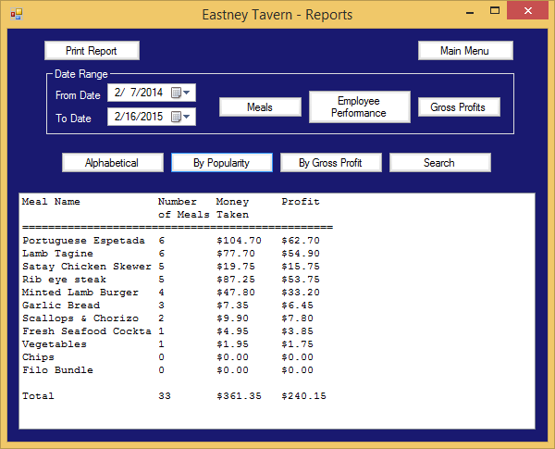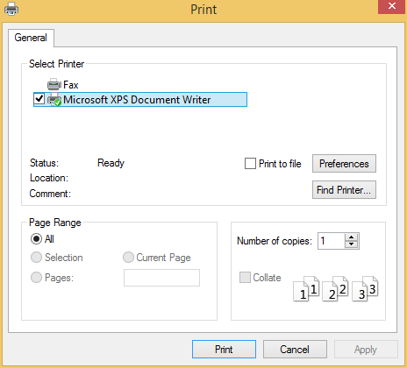

### Settings/Help

This is a miscellaneous sort of form, t Contains controls to add and remove menus, backup and restore the system as well as containing this help document.

#### Backup and restore

Here you can restore or backup the system by pressing the appropriate buttons. To backup click the button and select the folder you want to back up to.

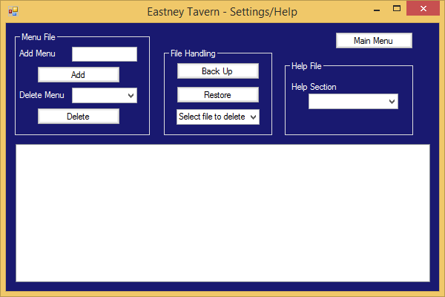

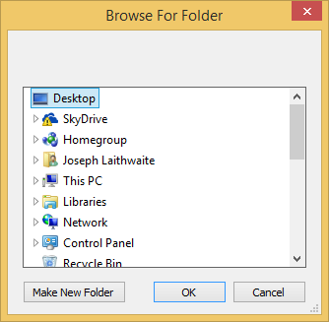

A folder is created in this directory, formatted Year_Month_Day-Hour_Minute

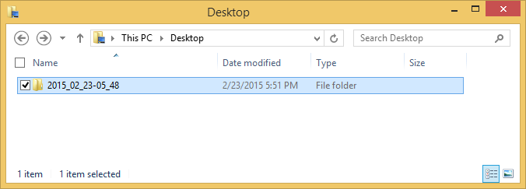

And is filled with the all the data files.

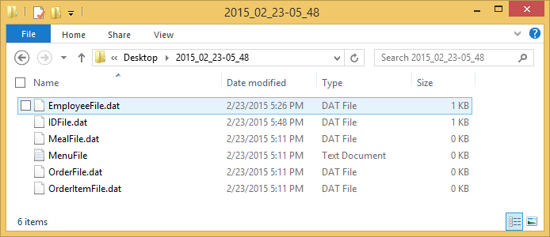

A backup is that simple.

To Restore

Click the restore button.

A Message will appear asking if you want to Backup saying yes follows the process above.

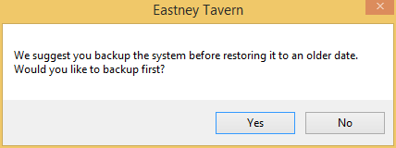

Otherwise you have to select a folder.

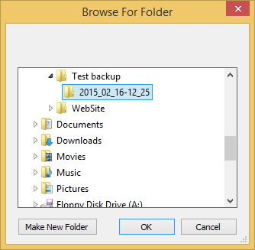

And the files are uploaded to the system overwriting the existing data.

#### Adding and Removing Menus

Adding or removing a menu is simple. To add a menu type its name into the “Add Menu” text box then click “Add”.

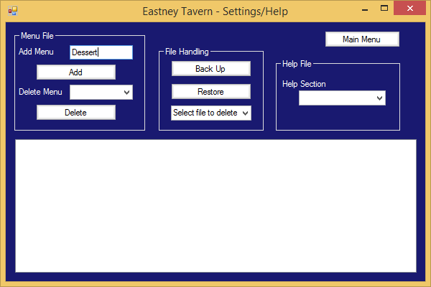

The menu is now saved and therefore can be selected to be deleted.

To delete the menu select it from the drop down box “Delete Menu” then click Delete.

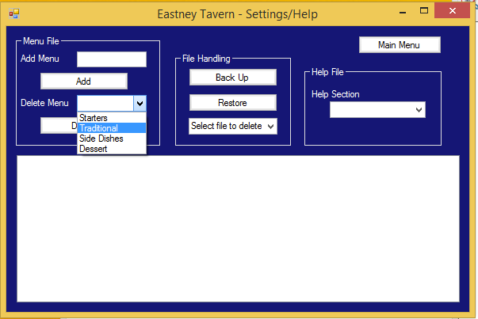

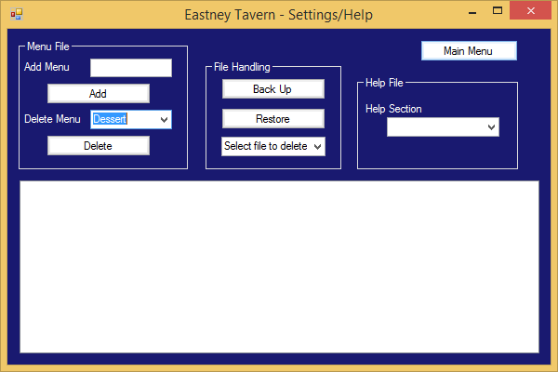

Agree to the dialogue box

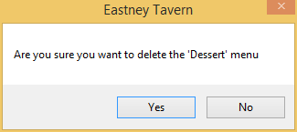

and the menu has now been deleted.

## Sample of error messages and error messages and error recovery procedures

### Login

If you try to login (press the “enter” button) before you’ve inputted an Employee ID then this error message will be shown.

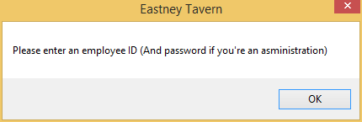

To get past this error you should enter your Employee ID (and password if you’re an administrator) then click the “Enter” button again.

If you enter a number, which isn’t a current Employee ID, then this error message will occur.

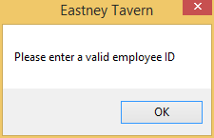

This error can be corrected by entering a valid Employee ID.

Entering a made up employee ID which contains non numeric characters will result in this error message.

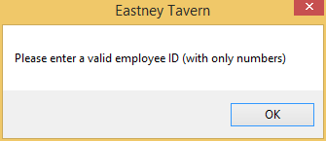

You should check you have a valid employee ID and try again. ID’s are only ever numbers.

Finally if you enter a valid ID but an incorrect password then this error message will be displayed

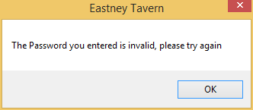

To correct this make sure you’ve entered your Password correctly (remember it’s case sensitive) and try again.

### Meals / Employees

The Meals and Employees forms have very similar data input procedures so the error messages are very similar and these are the common errors.

If you try to save a record without an ID then this error will be shown.

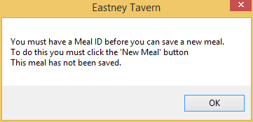

To resolve this error you must click the “New meal” or “New Employee” button so a new ID is created.

If you have an ID but nothing else this error message will be displayed.

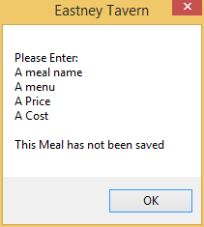

If only one or two things haven’t been entered this same error message will be shown but with only the missing items shown.

To correct these messages you have to enter data in the relevant box then try again.

If a data entry box, which should contain numbers, contains letters then this error message is shown.

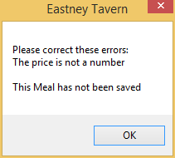

To correct this make sure the data entered are numbers.

### Reports

If no orders have been taken but you click either the “Meals”, “Employee Performance” or “Gross Profits” buttons then this error is displayed.

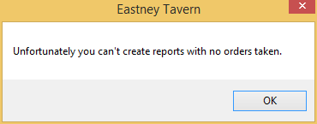

You must take orders before you create reports.

### Orders

Clicking the “Add” button before selecting or creating a new order results in this message.

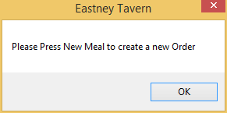

To fix this if you wish to create a new order click the “New Order” button, enter a table number then re-enter the meal and click “Add” again.

When you try to add a new order on a table that is already in use (an open order) this error message happens.

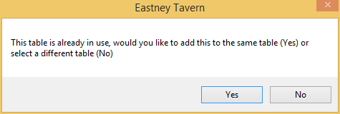

If you wish to add to the existing order click “Yes” and the meal is saved. However if you wish to add it to a different table then click “No”, a new dialogue box will appear, in here enter the new table number.

